**RUL PREDICTION OF LI-ION BATTERIES**

**USING LINEAR REGRESSION**

**Abstract:**

Longevity remains one of the key issues for Lithium-ion (Li-ion) battery technology. On-board Intelligent Battery Management Systems (BMS) implement health-conscious control algorithms in order to increase battery life while maintaining performance. For such algorithms, the information on the Remaining Useful Life (RUL) of the battery is crucial for optimizing the battery performance and ensuring minimal degradation. However, accurate prediction of RUL remains one of the most challenging tasks to this date. In this paper, we present an online RUL estimation scheme for Li-ion batteries, which is designed from a thermal perspective. The key concept on which the model is based on is the concept of ​**critical points. ​**The prediction of RUL is based on ​**what happens to a battery during its discharge cycle, ​**various parameters like temperature, voltage, current, resistance, etc continuously change during a discharge cycle. It will be ​**difficult to monitor the entire discharge cycle** thus from the various analysis we performed on the data we came up with the concept of critical points for these parameters and it turns out these critical points have ​a **strong linear correlation** with the capacity of the battery. A simple linear model like regression can be used for prediction.

**Data Analysis:**

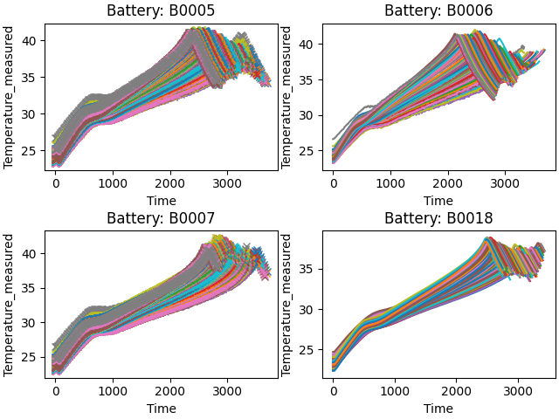

Temperature measured v/s Time

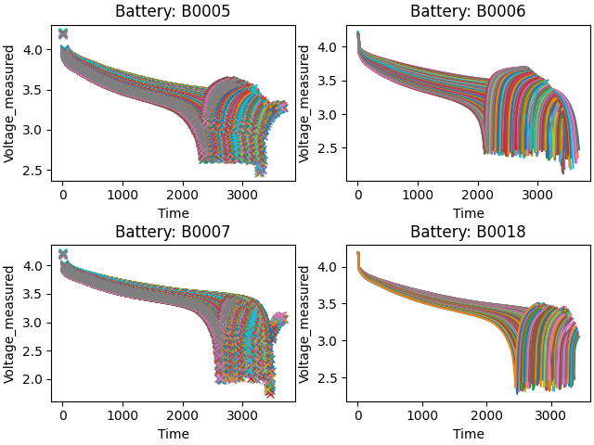

Voltage measured v/s Time

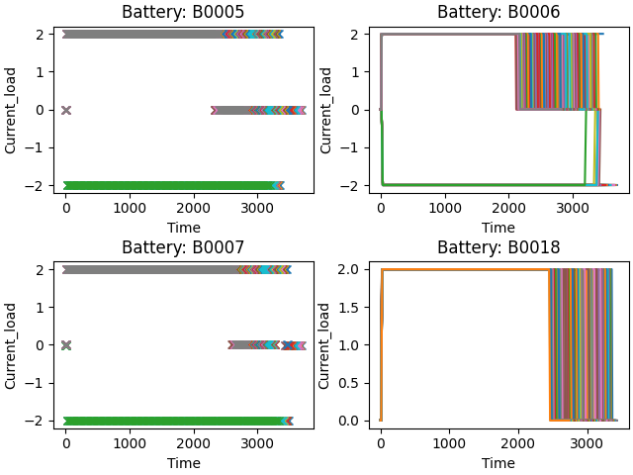

Current Load v/s Time

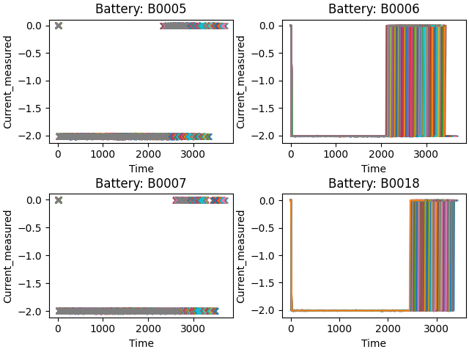

Current Measured v/s Time

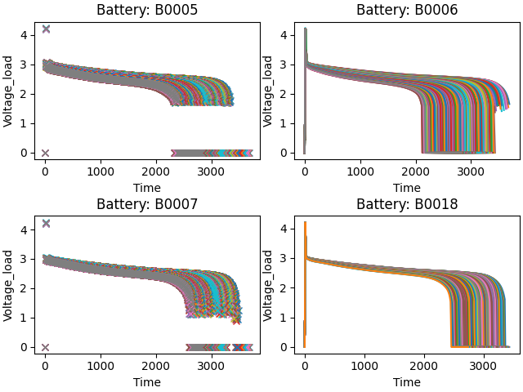

Voltage Load v/s Time

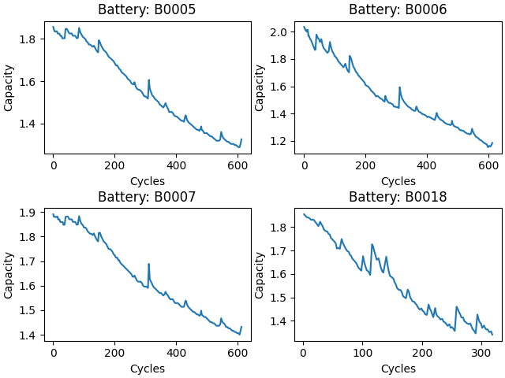

Capacity v/s Cycles

After plotting various parameters like Current Measured, Voltage Measured, Current Load, Voltage Load, Temperature against time, and Capacity against Cycles for four batteries, ​**we see a trend that the path of all the parameters is shifting as the cycle number is increasing.**

To study this ​**shifting trend** in more detail we plotted these parameters from **initial cycles and final cycles ​**and compared them against each other.

Plots for parameters vs time for the ​**first 20 cycles** and parameters vs time for the ​**last 20 cycles​** to study this shifting trend in detail can be found​ in the folder:

**Regression\PLOTS\Discharge\First**

**Regression\PLOTS\Discharge\Last**

**Critical Points**

In the given dataset every cycle is represented by a set of arrays. Out of which Temperature, VoltageMeasured, VoltageLoad seems to best describe the cycle. These values are measured at different time points which are represented in the Time array.

Rather than using the entire array for training we can extract ​**critical time points for each of the features** and train the model on these ​**critical time points. ​**Only using these ​**critical points​** will reduce the training time and reduce the noise in data.

Critical points are based on the ​**shifting trend** discussed earlier. **The entire path shift can be thought of as a shift in its critical point​**. We define critical points as follow

* **Temperature: ​**Time at Highest Temperature
* **Voltage Measured: ​**Time at lowest Voltage Measured
* **Voltage Load: ​**First time it drops below 1 volt after 1500 units of time

.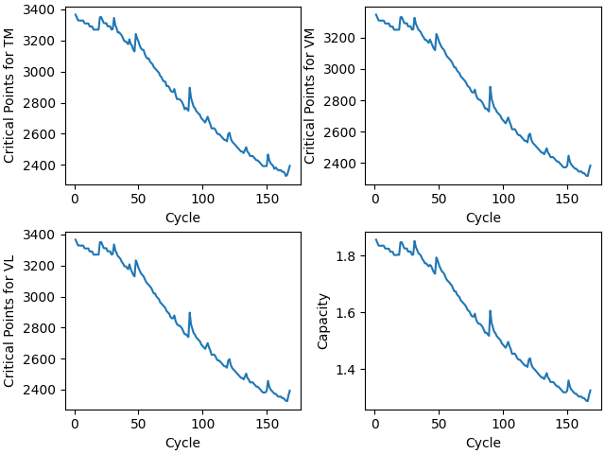

This is the plot for Battery B0005. Here cycle number is representing the age of the battery and with the increasing cycle number (age) ​**battery’s capacity decreases** and so do the ​**critical values.**

Thus from the plot, it is clear that there is a ​**strong correlation ​**in the data and a simple model like ​**Regression ​**can be used for prediction.

**Regression Model**

**MODEL 1**

To test the concept of critical values we first ​**only used one battery** i.e. B00​**05** and created a dataset consisting of critical values for above mentioned 3 parameters and capacity as the label for all the discharge cycles.

We trained the model on 75% data and 25% of the data was used for testing. we obtained an accuracy of ​**99.99037 ​**and an average absolute difference between predicted and the real capacity of ​**0.0001504**

**MODEL 2**

To test the accuracy of the model further we used ​**three batteries** B00​**05​**, **06​**, **07** and created a dataset consisting of critical values for above mentioned 3 parameters and capacity as the label for all the discharge cycles and combined the data for all 3 batteries.

We trained the model on 75% data and 25% of the data was used for testing. we obtained an accuracy of ​**99.158129 ​**and average absolute difference between predicted and real capacity of ​**0.0134047**

**Conclusion**

|  |  |  |
| --- | --- | --- |
| Metric | B0005 | B0005, 06, 07 |
| Accuracy | 99.99037 | 99.15812 |
| Avg. Difference | 0.00015 | 0.01340 |